AACT Mechanical Principles and Design
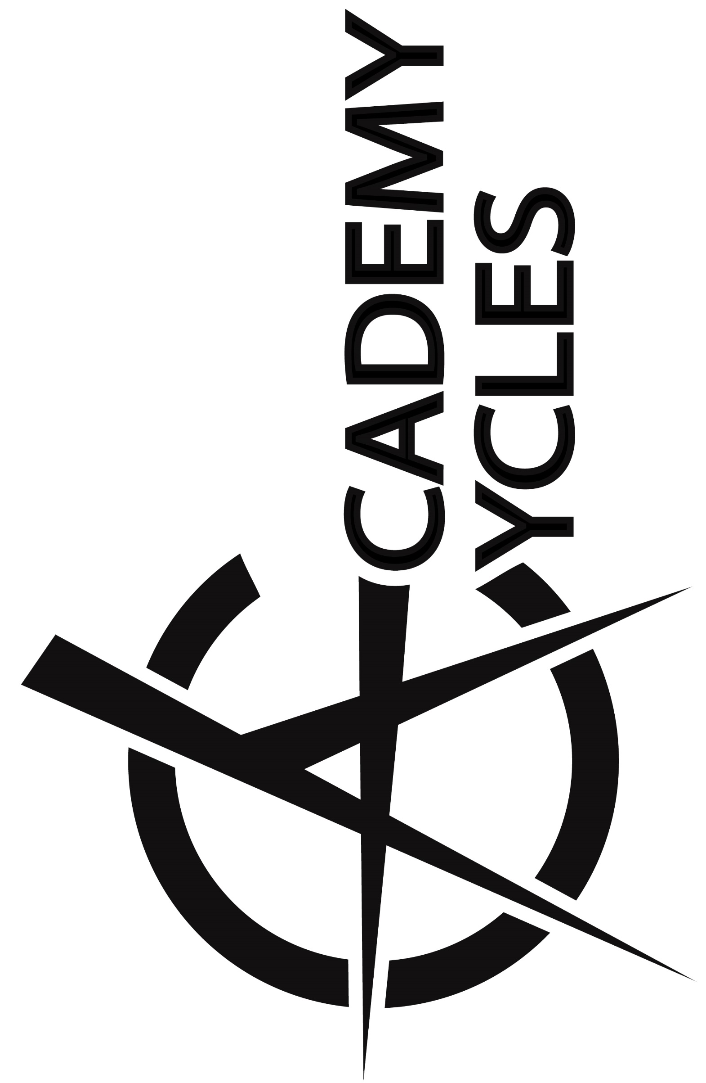
Instructor: Greg Burge
Welcome to AACT’s Academy Cycles. I am excited to have you in my Mechanical Principles and Design class! Bike Shop Class will use the bicycle to introduce you to engineering concepts like simple and compound machines, mechanical advantage, and friction, and efficiency. We will do this by studying the mechanics, service and repair of the bicycle. It will also introduce you to the proper application and use of a variety of tools used in everyday life.
This is a required class for students entering the Engineering and Manufacturing Academy, but it also intended to benefit any student with an interest in bikes. You will disassemble, repair, and rebuild used bicycles in this "hands-on" class with safety, craftsmanship and teamwork being stressed at all times.
Every student mechanic will become familiar with the following systems on a bicycle:
- Wheels: tires, tubes, Spoke lacing, and hub bearing assemblies
- Headsets, forks, and steering bearing assemblies
- Cranks and bottom bracket bearing assemblies
- Drivetrain systems including chain rings, gear cogs, and chains
- Brake systems
- Derailleurs and shifting systems
- Frame design, frame materials, and frame building
In addition to basic engineering principles, we will be studying the basics of shop operation and how to professionally conduct ourselves in the workplace.

Expectations- The expectations for this class and the shop in general are simple:
Be SAFE! Follow all safety instructions and procedures at all times. Eye Protection and aprons will be worn at all times in the shop.
Clothing: Students must wear closed toed shoes at all times. Bicycles on the stand contain moving parts. Protect yourself and your clothing at all times. Tuck in drawstrings, ties, and loose clothing before class. We work with grease and dirty bicycles, so dress appropriately and protect your clothing.
Be respectful! We will maintain AACT’s culture of mutual respect at all times.
Be appropriate! Academy Cycles will maintain professional standards of conduct at all times.
Be prepared! Come to class ready to learn and ready to WRENCH!
Have Fun! Bikes are awesome!

