AACT Senior Capstone Presentation 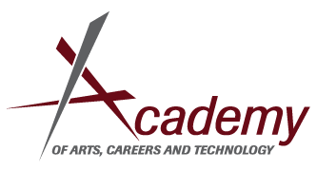
The purpose of your Capstone/Portfolio Presentation Speech is to promote you and AACT to a community panel.
- 8-10 minutes long, no more, no less
- Must contain some presentation technology, please see the attached sheet about the use of PowerPoint and similar tools; please let us know if you need any special equipment.
- Hook your audience! Show your successes! Use Pathos, Logos, Ethos. Use your speech!
Your Portfolio and your Capstone projects are intended to be the focal point of this presentation, but it must address all of the following:
- Your Past-where do you come from?
  - Previous Academics
  - Goals before AACT
- Academics at AACT
  - Highlight academic accomplishments
  - Focus on successes
- CTE
  - What is your academy? What is the focus of your academy? What CTE classes did you take?
  - Showcase any artifacts or successes.
  - Present any certifications, awards, or CTSO information
- Capstone
  - Project Overview
  - Statement of How Project Meets Requirements (Details Later)
  - Present Artifacts
  - Discuss Community Partnerships
- Service
  - Description of all service hours completed Sophomore and Junior year

- Your Future Plans
  - Where will you go next? How did you come to this conclusion? What are your short term goals? Long Term goals? How has AACT helped you reach these goals? How have you overcome challenges to reach these goals?
Don’t let this list rule your presentation. Be creative! Address these topics in whatever order works for you. You want to put your experiences in a positive light and focus on your successes and your strengths. Show this panel how you have grown; show them that you are ready to tackle the challenges that you will surely face and that you are a force to be reckoned with!
Public speaking is a scary thing, but everyone involved in this process wants to see you and help you succeed. Do what you always do: represent yourself and your school with brilliance!

