Senior Capstone Project
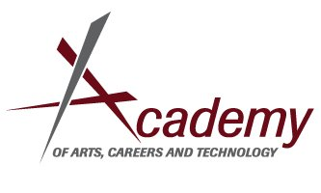
Project Description:
The purpose of the Capstone Project is to ensure that all AACT graduates have taken steps to prepare for meaningful citizenship and that they are college and career ready. Seniors will implement their project before March 14th of their senior year, and they will present their project as part of their Senior Presentation in May.
Purpose:
- Application of CTE and Academic skills to post-secondary life
- Network and contact building
- Portfolio development
- Personal assessment and reflection regarding K-12 Education and College/Career Readiness
Project Options:
- Service Project-Designed and implemented by student
- Job Shadow- Arranged by or approved by student’s Academy
- Internship- Paid position that is DIRECTLY connected to the student’s Academy-must include unpaid component
- Post-secondary class connected to college/career goals
Service Project Requirements:
- Must be connected to Core Academics and CTE Curriculum
- Must be approved by Advisor
- Project Advisor must be a CTE Instructor from your Academy
- Minimum of 60 Project Hours-DOCUMENTED
Job Shadow/Internship Project Requirements include the above and:
- Job Shadow/Internships of 30 hours or less will be accompanied by a modified 30 hour Service Project (Similar to Junior Small Group Project)
- Job Shadow/Internship must include at least 10 Hours of unpaid service
- Job Shadow/Internship proposals will be considered on a case by case basis

Timeline:
- Proposals Due In student’s English class, August 22/23rd (2nd Week of School)
- Abstract and Actionable Items List with Meeting Dates due October 3/4th
- Advisor Check in/ mini evaluation December 12/13th
- Project must be completed by Friday, March 14th
- Final Advisor Meeting and Evaluation Due to Mr. Burge by April 24/25th
- Portfolio/Capstone Presentation May/June TBA
Capstone Project and Presentation grade will be assessed in Senior English

