Accessing Clever (and the programs accessed via Clever)
Clever is a portal for students to login to online programs your child’s classroom teacher may be using.
The directions to login are as follows:
Note: Students will need their student ID and password used to login to the computer at school in order to login to Clever
STEP 1: Navigate to this website: https://clever.com/in/washoe
(Clever can also be accessed from the Students and Parents tab of the district website)
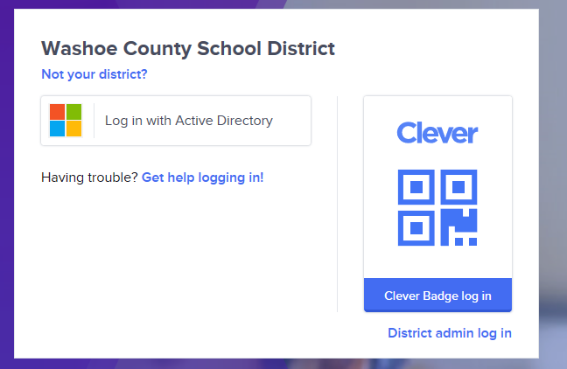
STEP 2: Click “Log in with Active Directory”

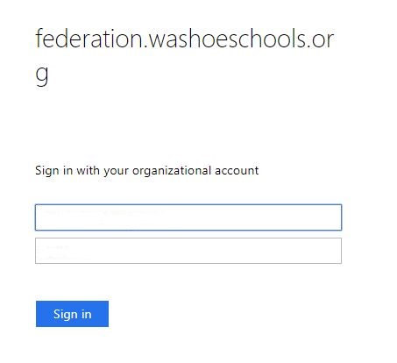
Enter password here
studentID@washoeschools.org
STEP 3: Log in with your username and password:
Username: Student ID@washoeschools.org
Password: password used to login to the
computer at school
(If accessing Clever on a District device this step
may be skipped)

STEP 4: Once inside Clever
Click on the icon for Paper you would
like to access. Depending on your
grade level/school you will have different options.

