History of the English Language Hamlet Introduction
Old English:
Beowulf ca. 800 AD
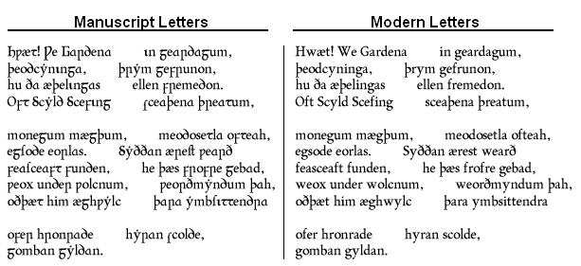

Middle English: Beginning on October 12, 1066!
WHAN that Aprille with his shoures soote
The droghte of Marche hath perced to the roote,
And bathed every veyne in swich licour,
Of which vertu engendred is the flour;
Whan Zephirus eek with his swete breeth | 5
Inspired hath in every holt and heeth
The tendre croppes, and the yonge sonne
Hath in the Ram his halfe cours y-ronne,
And smale fowles maken melodye,
That slepen al the night with open ye, | 10
(So priketh hem nature in hir corages:
Than longen folk to goon on pilgrimages,

Modern English: Shakespeare! 16th Century AD
To be, or not to be, that is the question:
Whether 'tis Nobler in the mind to suffer
The Slings and Arrows of outrageous Fortune,
Or to take Arms against a Sea of troubles,
And by opposing end them: to die, to sleep
No more; and by a sleep, to say we end
The Heart-ache, and the thousand Natural shocks
That Flesh is heir to? 'Tis a consummation
Devoutly to be wished. To die, to sleep,
To sleep, perchance to Dream; aye, there's the rub
For in that sleep of death, what dreams may come,
When we have shuffled off this mortal coil,
Must give us pause.

