Othello Literary Theme Analysis Assignment
This assignment is intended to take the place of a simple paper, but your project must show that you understand how Shakespeare makes meaning in Othello, just like a paper would. Your project must address the following things:
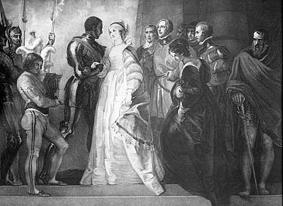
- A COMPLEX and sophisticated STATEMENT OF THEME.
- At least 7 (with at least one per act) significant quotes that are directly related to your theme.
- You must connect at least two characters to your chosen theme.
- At least 5 Literary Devices/Elements that Shakespeare uses to elucidate this theme.
i.e.: allusion, metaphor/simile, Irony, symbol, paradox, soliloquy, juxtaposition, diction, rhetorical devices, etc.
YOU MUST CONNECT THESE DEVICES TO YOUR THEME!

You may write a 3 page paper that addresses these criteria, or you may create a project from the following menu. I will use the above criteria to create a grading rubric, so make sure that you address each of the four requirements.
Project Ideas:
Promo Packet for your specific theme with a Banner, a t-shirt design, a bumper sticker, a button or a patch, and the script of a TV commercial.
Party Packet- must include an invitation, a guest list (with descriptions and reasons why they are invited), a menu, entertainment information, and a paragraph and picture from the society page of the local newspaper. All of these elements must address your theme!
Newspaper Packet: Must include three of the following sections and stories must address your theme and the requirements: Front Page, Sports, Editorial, Weather, Local News, Politics, Education, Arts and Culture Section.
Letter and Response: You may write a letter and a response between two real or fictional characters. They should include stamps, stationary, and envelopes that address your theme.
Map: This map may be of a real place or a symbolic place, but it must represent your theme and have a legend with symbols, annotations of specific events, illustrations and explanations.
Fine Art Project (Drawing, Painting, Mural, Sculpture, Diorama, Mobile, OR Music) this could be fun, but remember, your art has to address all of the above requirements.

All projects will be graded on creativity, neatness, and thoroughness.

