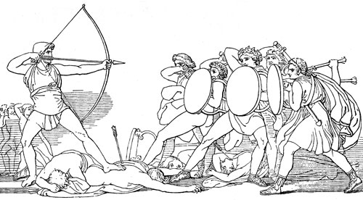
The Odyssey: BEST LINE ASSIGNMENT: For each of the following sections, choose a line or lines from the text that best represents that part of the poem. On your own paper, NEATLY write each line and translate it into your own language. Be sure to include the LITERAL meaning of any FIGURATIVE language. At least two of your lines must be HOMERIC SIMILES.
Choose your two favorite lines, and illuminate them on the paper that I will provide. Your Illuminations must be BEAUTIFUL, large enough to be visible when hung on the wall, and they must include a related image.
“Tell the Story” pg. 651- 1 line
“The Wanderings: Calypso the Sweet Nymph” pg. 652-654 2 lines
“I am Laertes’ Son” pg. 656-658 1 line
“The Lotus Eaters” pg. 658 1 line
“The Cyclops” pg. 660-670 3 lines
“The Enchantress Circe” pg. 673-674 1 Line
“The Land of the Dead” pg. 675-677 1 Line
“The Sirens; Scylla and Charybdis” pg. 678 683 3 Lines
“The Cattle of the Sun God” pg. 684-686 1 Line
“The Meeting of Father and Son” pg.691-694 1 Line
“The Beggar and the Faithful Dog” pg. 694-695 1 Line
“The Test of the Great Bow” Pg. 698-702 2 Lines
“Death at the Palace” pg. 703-705 2 Lines
“Odysseus and Penelope” pg. 706-709 3 Lines

