ACADEMY FOCUS:

This program prepares students for college of agriculture or veterinary medicine, immediate employment in a natural resource or animal science industry, and internships.
Program:  - Hands on experience with animals  - Use of hydroponics and other medium to grow many plant varieties and run greenhouse  - Job shadow and field trips to plant and animal facilities | Professional Student Organization:  - Future Farmers of America (FFA) | Tech Prep College Credits:  Students earn 9 credits from our end of program exams:  - Workplace readiness  - Greenhouse management  - Agribusiness  - Veterinary Science

Academy Classes

Freshman Year

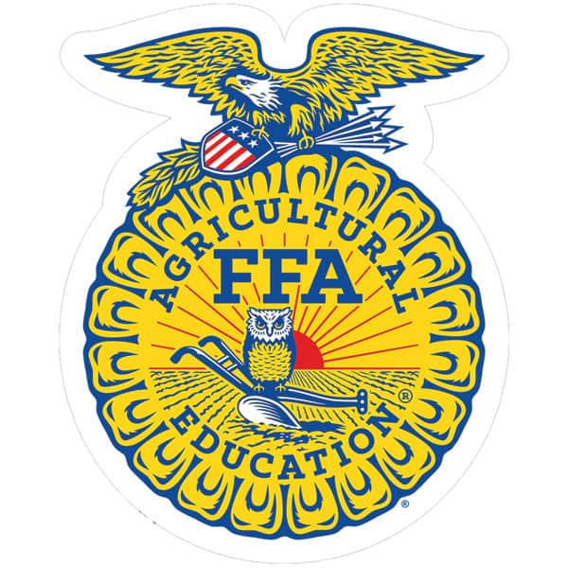
Agriculture Science I

Sophomore Year

Agriculture Science II

Plant Science Horticulture

Junior Year

Agribusiness

Greenhouse Management

Senior Year

Greenhouse Management

Veterinary Science

Future Farmers of America, otherwise known as FFA, is an agricultural national youth organization that prepares members for leadership roles, aides in personal growth and career growth.
Future Farmers of America

Short description of what your focus is and/or your involvement.
Short description of what your focus is and/or your involvement.
Insert Picture
Insert Picture
Insert Picture
Insert Picture
Insert Picture
Insert Picture
Insert Picture
Insert Picture
Insert Picture
Insert Picture
Insert Picture
(Your Focus)

(Your Focus)

Insert Picture
Insert Picture
Insert Picture
Insert Picture
Insert Picture

