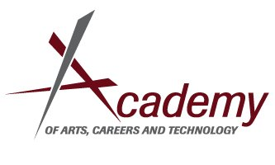

AACT Capstone Project Fall Check-in

Student Name ___________________________________________ Date_______________________________
Advisor___________________________________________________ Academy__________________________

Project Title ____________________________________________

The purpose of this October meeting is to verify the feasibility of the project, to discuss the first/next actionable steps, to schedule necessary check-in meetings before the final project evaluation. and to determine how you will verify that the project has been done:
To be filled out by student and advisor:
Tentative Meeting Schedule: You will need to meet before the week of December 9th to complete the Semester Check-in. What other meetings do you need to have before the final evaluation? When can you and your advisor meet?

How will your advisor verify that you have completed your capstone project? Some examples of verification are class transcripts, internship paystubs, signed project abstracts or overview sheets, telephone verification, and personal observations.

To be filled out by Advisor:
The Capstone Project is meant to be a bridge between High School and College or Career. It should be a culmination of a student’s Academic and Career/Technical Education. As an advisor, how well do you feel that this Capstone Project honors these criteria? Please rank this project from 1-5 (with five being the best ranking possible).

1 2 3 4 5

As an advisor, how prepared do you feel the student is to complete this project on time? Please rank this project from 1-5 (with five being the best ranking possible).

1 2 3 4 5

How professional and respectful of your time was the student? Please rank this (with five being the best ranking possible).
2 2 3 4 5

Advisor Signature__________________________________________ Please use the back of this sheet for comments.

