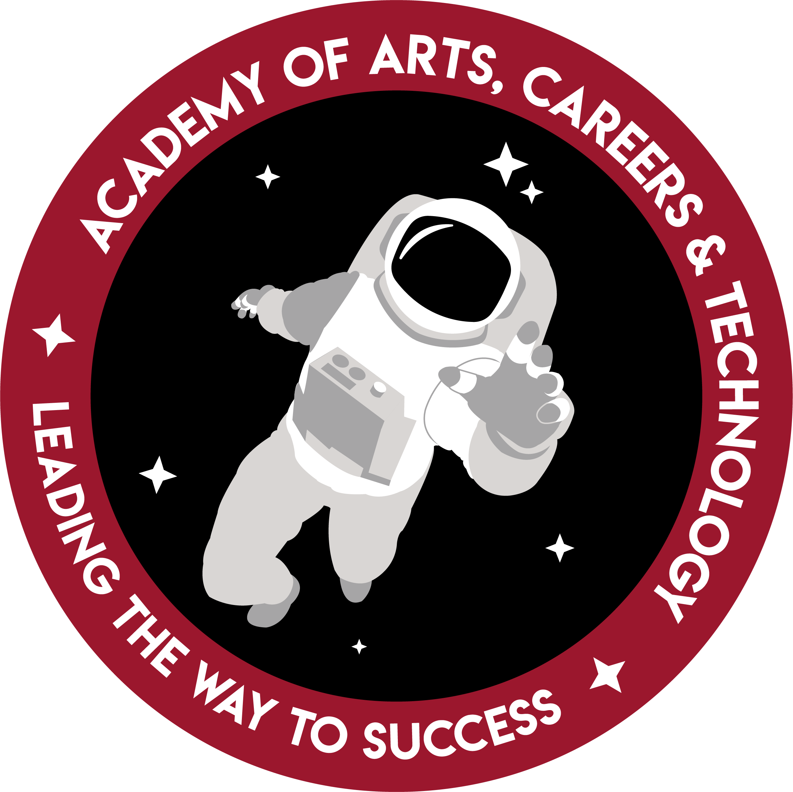

Natural Resources and Animal Sciences

CAREER FOCUS:
This program prepares students for college of agriculture or veterinary medicine, immediate employment in a natural resource or animal science industry, and internships.
PROGRAM:  - Hands on experience with animals  - Use of hydroponics and other medium to grow many plant varieties and run greenhouse  - Job shadow and field trips to plant and animal facilities | Professional Student Organizations:  FFA | Tech Prep College Credits:  9 credits may be earned

This academy gives students the opportunity to work in the agricultural field of careers. This academy offers agriculturally based classes including: Agriculture Science 1, Agriculture Science 2, Plant Science and Horticulture, Floriculture, Greenhouse Management, Natural Resources and Wildlife Management, and Veterinarian Science. Each student in this academy is a member of the National FFA Organization. Students can choose from a variety of Career Development Events (CDE’s) to practice and compete at a state and national level. NRAS students also have the opportunity to attend different leadership camps and workshops with other Nevada FFA chapters, as well as different community and school activities that our Sierra Nevada chapter is involved in.

High School of Business

CAREER FOCUS:
Prepared for college of business, immediate gainful employment in economics or finance, and paid internships.
PROGRAM:  - Apply business technology and related software for industry and personal use  - Earn national certification in financial literacy and person responsibility | Professional Student Organizations:  FBLA | Tech Prep College Credits:  9 credits may be earned

The Business Academy is a member of the High School of Business program and adopts the curriculum that goes along with it. In addition to this, students in this academy are in charge of running the vending machines and AACT’s student store. Students are also in charge of accounting, inventory, purchasing, and daily upkeep of these two business projects. In addition to their daily duties at school, the academy participates in the CTSO called FBLA, which stands for Future Business Leaders of America. Students compete in business-based competitions to grow their skills in varying business procedures.

Courses Taken:
- Principles of Business Marketing
- Leadership
- Wealth Management
- Principles of Business
- Business Economics
- Principles of Marketing
- Principles of Finance
- Marketing I
- Principles of Management
- Business Strategies
- Marketing II

Education and Training

CAREER FOCUS:
This program prepares students for college of education, immediate employment in childcare facilities, and internships.
PROGRAM:  - Manage and operate on-site preschool.  - Create and implement lesson plans for various age levels.  - Experience a variety of career field related to preschool and school-aged children. | Professional Student Organizations:  FCCLA | Tech Prep College Credits:  9 credits may be earned

The Education and Training Academy, formerly known as the Early Childhood and Elementary Education program at AACT, has undergone significant curriculum changes. The students who are involved in this academy learn employability skills, developmental theories, social psychology, ethics, legal policies and safety along with self-exploration, in order to be prepared to succeed in a multitude of career fields, including the following: education, healthcare, psychology, social work, pathology and audiology. Through the level one Education and Training course, students will be able to develop talents in others and learn how to work with youth of different ages. The skills acquired can be used toward many career fields.

Culinary and Hospitality

CAREER FOCUS:
This program prepares students for culinary/hospitality college, immediate employment or apprenticeships in the culinary
or hospitality industry, and internships.
PROGRAM:  *Exposure to professionals who guide learning.  *Practice in leadership, acting as sou chef or manager.  *Develop skills through field trip and daily practice in state-of-the-art facility. | Professional Student Organizations:  SkillsUSA  Pro Start | Tech Prep College Credits:  21 credits may be earned

The Culinary and Hospitality Academy prepares students to go into the culinary field. The classes offered to the culinary students are Intro to Culinary, Culinary 1, Culinary 2, Culinary 3, Baking 1, Baking 2, Baking Advanced Studies, Hospitality 1, and Hospitality 2. The Culinary 2 and 3 classes run the restaurant and the Bakery, which provides students with real-life experience in the culinary field. Culinary students also participate in community events, such as March of the Dimes, the Boys and Girls club, and Showcase. These culinary students are offered the opportunity to gain up to 15 certifications, including their SERV Safe certification. Most of the students in this academy work in the field, including one student, who works as a cake decorator. Students also are accepted to many major culinary colleges across the country, such as Johnson and Whales.

Medical and Health Sciences

PROGRAM:  - Experiences in hospitals, clinics, and medical offices  - Gain skills in medical terminology, disease prevention and treatment, medical management systems.  - Exposure to a wide range of medical professions. | Professional Student Organizations:  HOSA | Tech Prep College Credits:  8 credits may be earned

The Medical Academy provides students with experience in the medical field. The academy is taught by Mrs. Urrutia and Mr. Mackey, a REMSA employee. Some of the classes offered are CERT, EMS, Heath Occupations, EMT, Anatomy, and Medical Terminology. Academy students have the chance to volunteer at hospitals and compete in HOSA competitions. Our HOSA Chapter works hard to include the entire academy in HOSA activities and classes. While in CERT, students can become teen CERT certified and get their FEMA 100 and 200 certifications. While in EMS, students can become CPR certified and basic first aid certified. At the end of the EMT course, students can become a certified EMT.

Communication, Arts, and Media

CAREER FOCUS:
This program prepares students for college in advanced media studies,
for immediate employment in animation, graphic design and videography, and apprenticeship or internship.
PROGRAM:  - Create two & three dimensional computer animation and graphics for web, game, and film industries.  - Develop skill in areas of graphic design including advertising, web design, and publishing.  - Produce digital video for broadcast news, television & film. | Professional Student Organizations:  SkillsUSA  Student Television Network  FFX | Tech Prep College Credits:  14 credits may be earned

The Communication Arts and Media Academy is an academy that teaches students to use technology in order to communicate. This academy deals mostly with visual arts, with classes Animation I (3D and 2D), Graphic Design I, II, III, and Video Production I, II, and III. The academy is run by two teachers, Robert Zorn (Video Production) and Rachel Robinson (Graphic Design). In these courses, students learn how to create visually pleasing works and how these works impact the viewer. Each class deals with ads and videos that could possibly be seen or distributed throughout the community. Students put together portfolios and reels of their works at the end of each year, posing as a type of technological resume.

Engineering

CAREER FOCUS:
Prepared for college of engineering or architectural study, trade schools in design,
metal working technology or welding/fabrication, and immediate employment, and internships.
Think - Design – Build
PROGRAM:  - Plan, design and build useful technology for the community and society.  - Develop skills in design and production using human powered vehicles.  - Develop employability through collaboration & teamwork activities. | Professional Student Organizations & Activities:  SkillsUSA  NASA Great Moonbuggy Race | Tech Prep College Credits:  19 credits may be earned

The Engineering Academy provides students with instruction in the industry standard welding practices. Areas of study include print reading, measurement, properties of metals, SMAW, GMAW, FCAW, GTAW, thermal cutting, codes, inspections, and certifications. This program prepares welding technology students for the American Welding Society (AWS) certification tests. They also learn principles of technical and architectural drafting and design concepts. Areas of study include sketching, dimensioning and annotation, construction and engineering documentation, 3D modeling, problem solving, critiquing, and team building.

